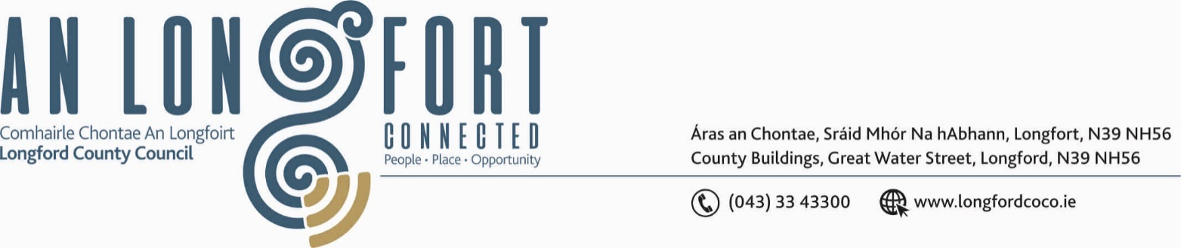

Meeting to be held in the Council Chamber and on Microsoft Teams

**22u Meitheamh 2022.**

**Chuig: Gach Ball don Chomhairle.**

A Chomhairleoir,

Iarrtar ort bheith i láthair ag Cruinniú Ginearálta Bliantúil Chomhairle Chontae Longfoirt a tionólfar i Seomra na Comhairle, Aras an Chontae, Longfoirt nó ar Microsoft Teams, Dé Céadaoin, 29 Meitheamh 2022 ag 3.00i.n. chun gnó a dhéanamh mar atá leagtha amach ar an gClár Oibre faoi seo.

You are requested to attend the Annual Meeting of Longford County Council to be held in the **Council Chamber, Aras an Chontae,** **Longford or on Microsoft Teams** on **Wednesday 29 June 2022 at 3pm.** to transact business, as set out on the Agenda hereunder.

Mise le meas,

Ann Marie Mc Keon

_______________

**Ann Marie Mc Keon,**

**Meetings Administrator.**

**C L Á R**

Prayer before Meeting.

**1. Election of Cathaoirleach.**

**2. Election of Leas Cathaoirleach.**

